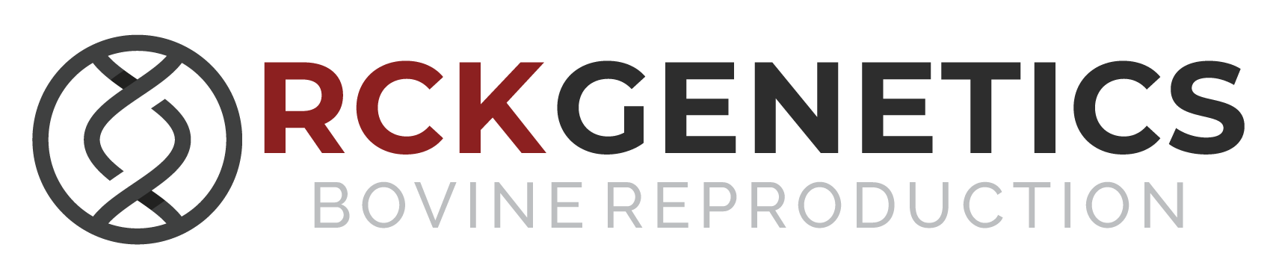

The health and safety of our family, staff, and customers is important. Due to the recommended health practices of our state and national government, and in order to support efforts to contain the spread of COVID-19, RCK Genetics will be rescheduling its Bovine Artificial Insemination and Pregnancy Determination Training Course. It was originally scheduled for April 30, 2020 thru May 2, 2020. The new dates for the courses are as follows:
Bovine Artificial Insemination Training
- June 12 & 13, 2020
- Friday class begins at 5pm
- Saturday class begins at 9am

Pregnancy Determination Training
- June 14, 2020
- Sunday class begins at 9am

If you have already pre-registered for the April class you can get a full refund or be moved to the June class. Email or call Brandi to let her know which you prefer. Thanks for your understanding and we can’t wait until this all passes and we can return to full operations. May God bless you and keep you safe.

Ricky & Brandi White
info@rckgenetics.com or 501-940-6953

